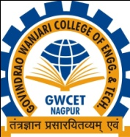
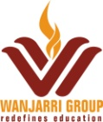
Govindrao Wanjari College of Engineering & Technology, Nagpur
One Week
Faculty Development Programme
ON
“Artificial Intelligence & Machine Learning”
From 21/01/2020 to 25/01/2020
Registration Form
- Name: ____________________________________________________
- Designation:________________________________________________
- Organization:_______________________________________________
- Qualification:_______________________________________________
- Correspondence Address:_____________________________________
___________________________________________________________
___________________________________________________________
- Tel No (Off)_____________________ (Res)_______________________
(Mob)___________________________
- Email-Id_____________________________________________________

Date: Signature of Participant

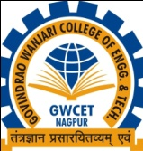
Govindrao Wanjari College of Engineering & Technology, Nagpur
One Week
Faculty Development Programme
ON
“Artificial Intelligence & Machine Learning”
From 21/01/2020 to 25/01/2020
Receipt
Name of Participant__________________________________________________
Amount____________________________________________________________
Date: Receiver Signature

