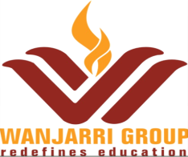
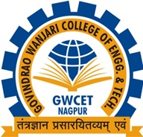

2.4.2 Honours and Recognitions Received by Teachers
2.4.2 Received awards, recognition, fellowships at State, National, International level from Government, recognized bodies during the years
Year of Award | Name of full time teachers receiving awards from state level, national level, international level from Government, recognized bodies. | Designation | Name of the award, fellowship, received from Government or recognized bodies
2018-19 | Dr. Hemant Sonare | Director & Associate Professor | "Cotton Vidharbha” Assocon Award-2018 by India ITME society.

DR. HEMANT SONARE (DEPARTMENT OF MBA)
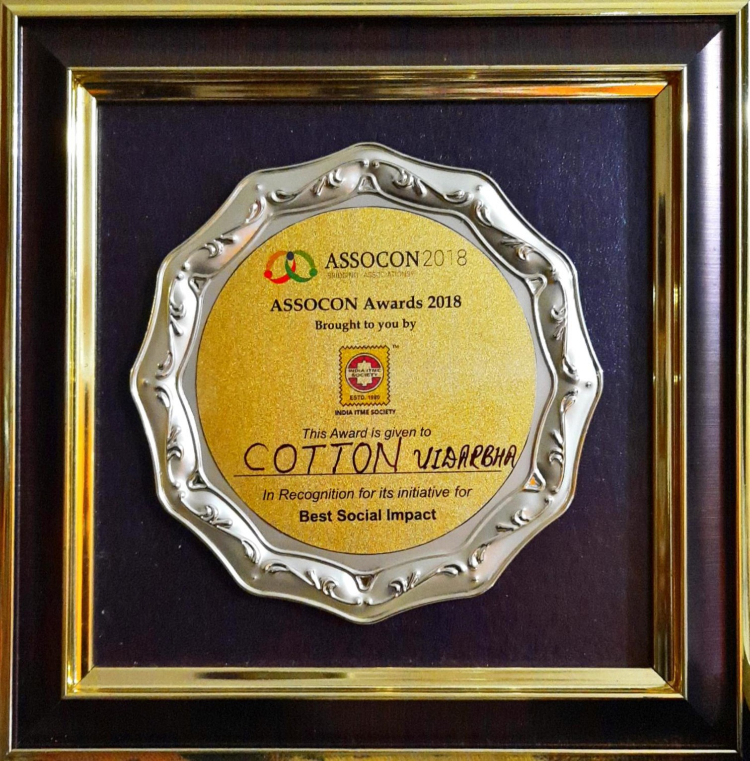

Dr. Hemant Sonare, Director, Wanjari Group of Institution and Associate Professor, Department of MBA Received "Cotton Vidharbha” Assocon Award-2018 by India ITME society.

